**Practical- 4**

**Aim: -** Making of cross cable and straight cable

* **Ethernet straight-through cable**
* In this cable wire a placed in the same position at both ends. The wire at pin 1on one end of the cable connects to pin 1 at the other end of the cable. The wire at pin 2on the other end of the cable; and so on.
* The following table lists the wire positions of the straight-through cable on both sides.

|  |  |
| --- | --- |
| Side A | Side B |
| Green White | Green White |
| Green | Green |
| Orange White | Orange White |
| Blue | Blue |
| Blue White | Blue White |
| Orange | Orange |
| Brown White | Brown White |
| Brown | Brown |

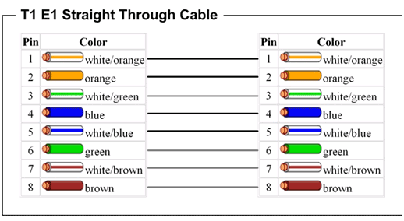

A Straight Cable is used to connect the following devices: -

1. PC to Switch
2. PC to Hub
3. Router to Switch
4. Switch to Server
5. Hub to Server

* **Ethernet Cross over Cable**

In this cable, transmitting pins of one side connect with the receiving pins of the other side

The Wire at pin 1 on one end of the cable connects to 3 pin at the other end of the cable. The wire at pin 2 connects to pin 6 on the other end of the cable. Remaining wires connect in the same position at both ends.

The following table lists the wire positions of the cross-over cable on both sides.

|  |  |
| --- | --- |
| Side A | Side B |
| Green White | Orange White |
| Green | Orange |
| Orange White | Green White |
| Blue | Blue |
| Blue White | Blue White |
| Orange | Green |
| Brown White | Brown White |
| Brown | Brown |